Instructions: Write the necessary queries on this page, as well as a screenshot of the response of the query on your command line

e.g: Find the number of documents on the database:

db.persons.find().count()

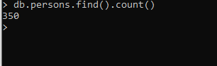

1. Add a document to the Database with the following parameters
   1. Name: yourName
   2. isActive: true
   3. age: yourAge
   4. gender: yourGender
   5. eyeColor: yourEyeColor
   6. favoriteFruit: array of favorite fruits
   7. company :

{title:”PN”

email:”USC email”

phone:”number”

location:

{country:”Philippines”,

Address:”Talamban, Cebu City”

}

}

> db.persons.insertOne(

... {

... name: "Jaynard Senilla",

... isActive: true,

... age: 19,

... eyeColor: "black",

... favoriteFruit: ["mango","banana"],

... company: {

... title: "PN",

... email: "19104860@usc.edu.ph",

... phone: 09878764323,

... location: {

... country: "Philippines",

... Address: "Talamban, Cebu City"

... }

... }

... }

... )

{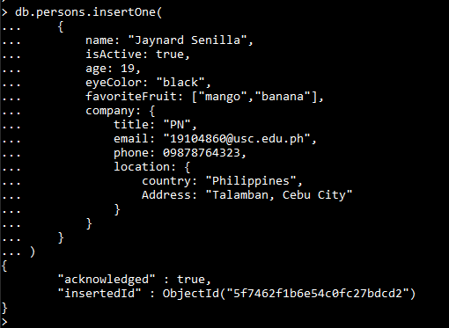

1. Add a document with the same parameters above but this time insert the information of 3 of your classmates with one query

Query: db.persons.insertMany([{

... name: "Harvey Aparece",

... isActive: true,

... age: 19,

... eyeColor: "black",

... favoriteFruit: ["mango","banana"],

... company: {

... title: "PN",

... email:"19104865@usc.edu.ph",

... phone: 09878764323,

... location: {

... country: "Philippines",

... Address: "Talamban, Cebu City"

... }

... }

... }],

... [{

... name: "Precy Jane Roxas",

... isActive: true,

... age: 19,

... eyeColor: "black",

... favoriteFruit: ["banana"],

... company: {

... title: "PN",

... email: "19104900@usc.edu.ph",

... phone: 09878764323,

... location: {

... country: "Philippines",

... Address: "Talamban, Cebu City"

... }

... }

... }],

... [{

... name: "Ailyn Albores",

... isActive: true,

... age: 19,

... eyeColor: "black",

... favoriteFruit: ["lansones","banana"],

... company: {

... title: "PN",

... email: "19104862@usc.edu.ph",

... phone: 09878764323,

... location: {

... country: "Philippines",

... Address: "Talamban, Cebu City"

... }

... }

... }]);



1. Find all the documents with the gender female

Query:db.persons.find({gender; “female”})

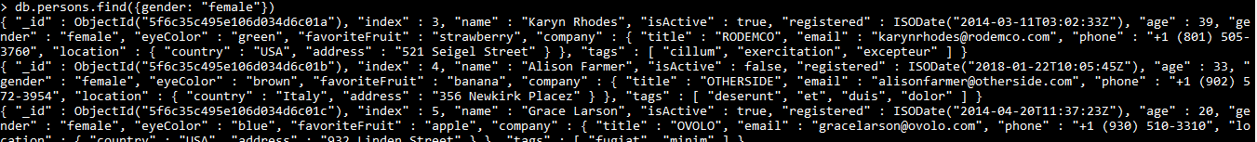

1. Find all the documents with the gender female and an age between 20 to 35

Query: db.persons.find({gender:”female”,age:{$gt: 20,$lt: 35}})

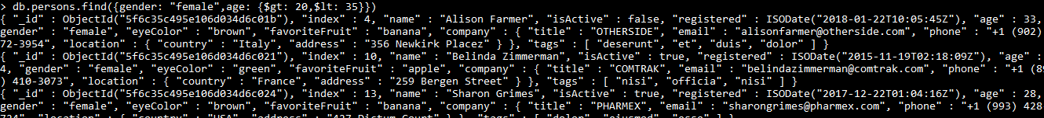

1. Find all documents with the company title “CANDECOR”

Query: db.persons.find(‘company.title’: “CANDECOR”)



1. Find the NUMBER of documents with the eye color of blue

Query: db.persons.find({eyeColor: “blue”}).count()

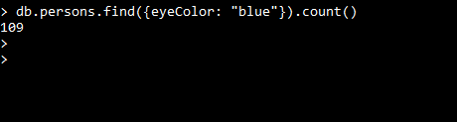

1. Find the documents with a favorite fruit of banana

Query: db.persons.find(favoriteFruit: “banana”)

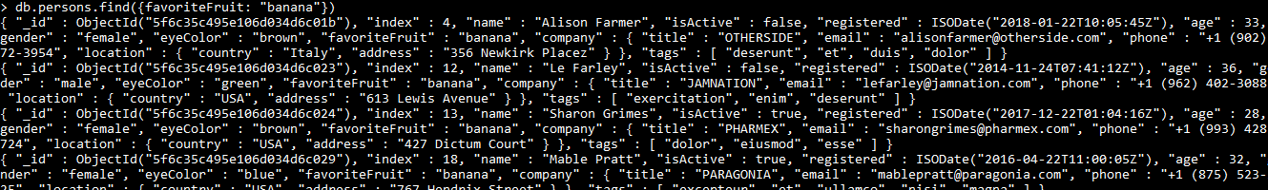

1. Find the NUMBER of documents with isActive:true

Query: db.persons.find({isActive: true}).count()



1. Find the documents with isActive: true and of a gender male

Query: db.persons.find({isActive: true,gender:”true”})

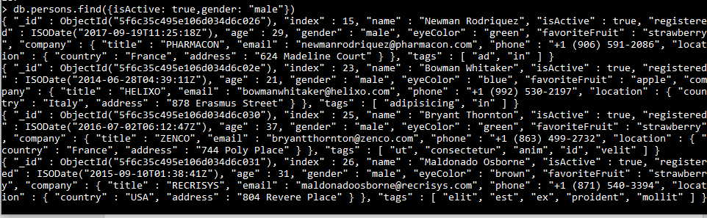

1. Find the documents with isActive: false , gender female, and an Age between the range 25 to 40

Query: db.persons.find({isActive: false, gender: “female”, age: {$gt: 25, $lt: 40}})

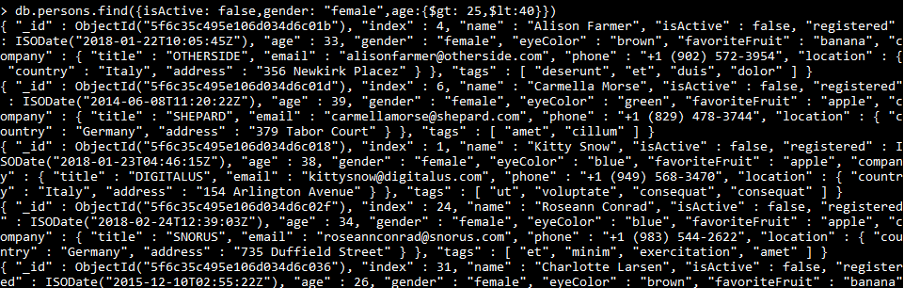

1. Find the documents that have both tags : “pariatur” and “veniam”

Query: db.persons.find({tags: {$elemMatch:{$eq: “partiatur”,$eq: “veniam”}}})

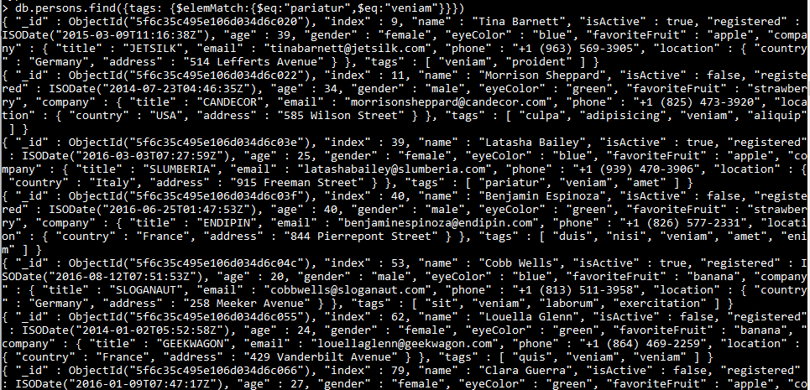

1. Find the documents that have either gender Male or eye color of Green

Query: db.persons.find({$or: [{gender: “female”},{eyeColor: “green”}]})

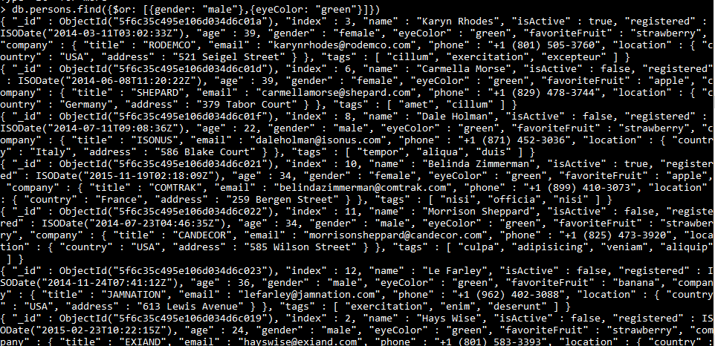

1. Find the documents with the age EITHER below 28 or above 35, thus documents with age 29,30,31,32,33,34 should not be included

Query: db.persons.find({$or: [{age: {$gt: 35}},{age: {$lt: 28}}]})

